Stats Video Lectures – Evaluating Normal Dist

Week 2, Video 9

1. how to tell if a dist is nearly normal probility plot or not
   1. normal prob plot, data is plotted on y axis, theoretical quantiles following a normal dist are plotted on the x axis
   2. if there is a 1 to 1 ratio between x and y (y=x), then the data follow the normal model

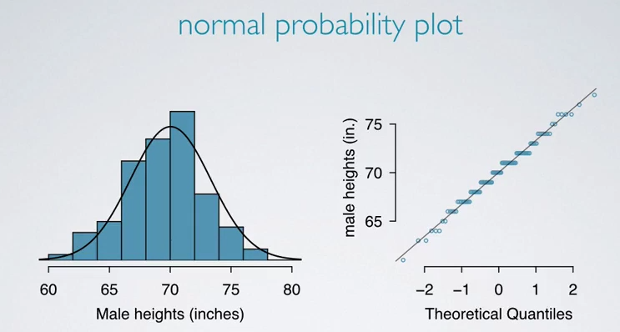

* 1. how to make a quantile plot in R

1. x = vector
2. >
3. n = length(x)
4. >
5. plot((1:n - 1)/(n - 1), sort(x), type="l",
6. main = "Quantiles for the NYC Rain Data",
7. xlab = "Sample Fraction",
8. ylab = "Sample Quantile")
   1. we also expect the data to follow the 68-95-9937% rule in order to be considered nearly normal